**INSTAGRAM USER ANALYTICS**

**Introduction**

By cloning available datasets into MySQL Workbench by using SQL queries, this project will conduct a thorough analysis of how users interact with the Instagram platform. This analysis will assist the product team in developing new features that will enhance the site's usability.

The two main areas of this project's attention are marketing and investor metrics.

The insights must be put into practice and provided to the product development team based on user involvement and the data gathered. That involves

* Rewarding Loyal Users.
* Remind Inactive Users to Start Posting.
* Declaring Contest Winner.
* Hash tag Researching.
* AD Launch Campaign.
* User Engagement.
* Bots & Fake Accounts.

**Tools Used**

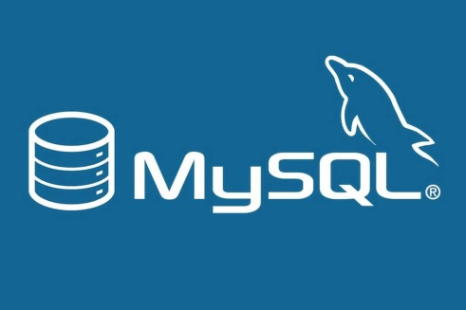

MySQL Workbench version 8.0.34



Microsoft® Excel® 2016 MSO (Version 2212 Build 16.0.15928.20002)

**Insights**

1. **Marketing Analysis**
2. **Rewarding Loyal Users:**

Here are the Top 5 Instagram Users

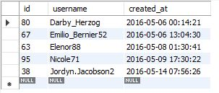

Code:

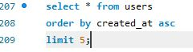

1. **Remind Inactive Users to Start Posting:**

Here is the list of Inactive Users who haven’t posted any photos on Instagram

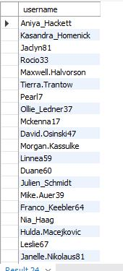

Code:

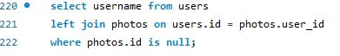

1. **Declaring Contest Winner:**

The User **Zak Kemmer_93** with **photo_id: 145** have got more number of likes (48) among all other existing users, so this user is declared as contest winner.

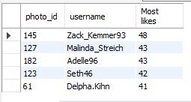

Code:

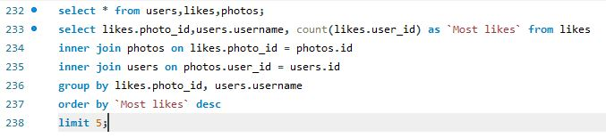

1. **Hash tag Researching:**

Here the most used hash tag was **“Smile”.** It was used **59 times** followed by “Beach” and “Party” with 42 and 39 times respectively.

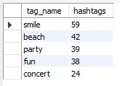

Code:

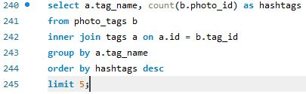

1. **AD Launch Campaign:**

Here the most users register on instagram was on **Thursday** and **Sunday** with **16** people registering into it followed by Friday with 15 people. So the efficient day to launch an advertisement campaign was on either a Thursday or Sunday or on both days.

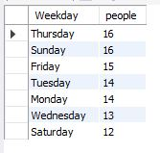

Code:

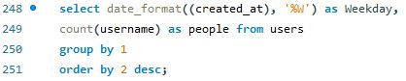

1. **Investor Metrics**
2. **User Engagement:**

Total Users: 100

Total Photos: 514

On an Average around 5 photos per user.



Code:

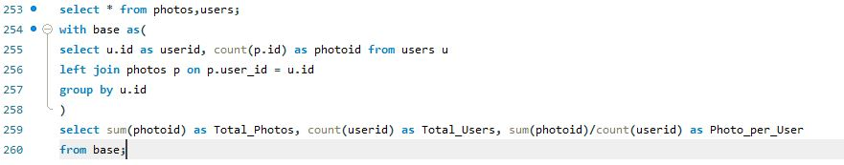

1. **Bots & Fake Accounts**:

According to the data, there is no photo which has a total likes of over 100 thus it is safe to say that the entire users who are registered are genuine.

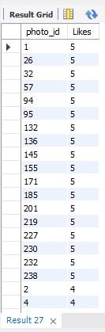

Code:

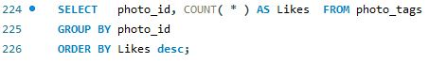

**Conclusions:**

The project offers the necessary insights important for the production team by providing the necessary answers to the inquiries.

With the help of this project, I was able to improve my SQL and Excel skills as well as my understanding of how data can be useful to a business.